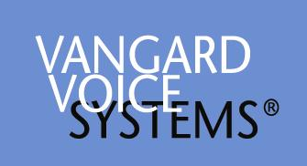

The
AccuSPEECH® SDK
Featuring the
FormSuite Studio

Preliminary User’s Manual

Windows® Version

For More Information Contact:

Vangard Voice Systems, Inc.
22382 Ave Empresa
Rancho Santa Margarita CA 92688
949.888.5262
www.vangardvoice.com

Table Of Contents

AccuSPEECH® FormSuite Studio 4
Introduction 4
The “Supported Environments and Caveats 5
Some Helpful Definitions 5
The Process of Adding Speech Functionality to Programs 7
Elements of the AccuSPEECH™ Studio 9
Project Management 10
Creating a new project 10
Exploring a Project 11
Building a Project 11
Grammar Creation 12
Using the Grammar Wizard 12
Using the Grammar Editor 14
Speech Object Definition 15
Using the Object Wizard 15
Using a Text Editor 16
Grammar Testing 17
Creating New Grammars – A Brief Tutorial 19
Voice-Enabling Web Pages 21
Web-Based Applications 21
Preparing an HTML script 21
AccuSPEECH® SDK 24
Elements of the SDK 24
Supported Development Environments 24
Theory of Operation 24
Source Code Integration 25
Application Startup 25
Application Termination 25
Window Activation 26
Focus Changes 27
Starting and Stopping Recognition – PocketPC Style 27
Starting and Stopping Recognition – Windows 2000/XP Style 28
Speech Enabling Web Pages – Windows 2000/XP 29
Browser Requirements 29
Basic Web Page Requirments 29
HTML/Javascript Code Integration 29
Appendices 31
Appendix A - Installation Instructions 32
Installing the AccuSPEECH® SDK 33
Runtime System Configuration – PocketPC 34
Runtime System Configuration – Windows 2000/XP 36
Appendix B - AccuSPEECH® API Function Reference 38
Appendix C - AccuSPEECH® BNF Language Definition 50
LANGUAGE ELEMENTS 51
LANGUAGE DEFINITION CONVENTIONS 51
LANGUAGE CONSTRUCTS 51
EXAMPLES 56
Appendix D - AccuSPEECH® Semantic Function Reference 58
Appendix E – AccuSPEECH® ActiveX/COM Interface Reference 72

AccuSPEECH® FormSuite Studio

This document describes the features and operation of the AccuSPEECH FormsSuite Studio. The Studio is an integrated set of tools that dramatically simplifies the process of adding speech functionality to Windows applications using the AccuSPEECH technology. The design of the Studio’s user interface will allow those familiar with Microsoft’s Visual Studio or Borland’s “Builder” products very quickly to become productive.

Introduction
The “promise of speech processing” has been touted for years – but has never really come to fruition. Vangard Voice Systems, Inc. was founded on the premise that speech input and output could be a useful tool IF the technology was focused on problems that the business community did indeed view as problems.

Almost all business operations fill in forms that capture information about their customers, operations, materials, etc. In many cases, it would be highly useful to be able to use forms in hands-free / eyes-free environments and speech is the natural interface for this task.

Accordingly, Vangard has developed a suite of tools that allows speech features to be easily added to forms applications. Entry fields in forms can be given the capability to “listen” for specific words, wordlists or commands, and information from a connected IT system can be “spoken” to users.

Our suite of tools consists of three classes of items:
- The AccuSPEECH FormSuite Studio, a graphic development environment that facilitates the process of adding speech features to objects in forms or programs;
- The AccuSPEECH Client, a runtime package that resides on each speech enabled device (PDA, Tablet, Laptop, etc) and which executes the speech objects attached to the objects in the forms or programs;
- The AccuSPEECH API, which exposes the full functionality of the Client to the advanced programmer.

This suite of tools can provide the enterprise with substantial saving in development effort when adding speech capabilities to applications:
Time savings: Order of magnitude time savings are not uncommon – you can voice-enable applications in hours or days, NOT weeks or months
Code savings: Even more dramatic savings in the amount of code written are regularly observed – rather than adding 40 pages of code, AccuSPEECH technology produces the same result with less than a page of added code.

The “Supported Environments and Caveats
This version of the Studio described in this document runs on Windows 2000 or Windows XP platforms. It is intended to voice-enable C or C++ programs that will be run on platforms using the PocketPC 2003, Windows 2000 or Windows XP operating systems. This version of the Studio is entirely compatible with applications written using the Microsoft Foundation Class Application Framework.

Future versions of the Studio will support other operating systems and application implementation languages.

It is not the purpose of the Studio to CREATE applications programs. Rather, it is intended to be used to add speech functionality to Windows C or C++ programs that are already in existence. Accordingly, when first using the Studio, be sure to have at hand a simple application program for trial purposes.

A sample program is provided on the installation disc.

Some Helpful Definitions
Throughout this document a number of terms will be used which may be unfamiliar to the user or may have some meaning in another context that differs from the meaning intended by the authors of this document. Here are the definitions of the terms as used in this document.

Terminal Expression – A token that is completely resolvable to a specific finite set of words.

Rule – A single, semi-colon terminated expression that specifies an atomic recognizer interaction that ultimately can be resolved to terminal expressions only. May reference other rules and have repeat and optional operators. Usually include a production clause that specifies the actual output (as a substitution for what is actually recognized) and/or some action to be performed.

Grammar – A collection of rules. One of the features of the AccuSPEECH™ system is the dynamic management of Grammars. When a grammar is activated by virtue of the referencing Speech Object coming into scope all rules within the grammar are active.

Grammar Set – An organizational construct used by the recognizer to group grammars into related groups. Grammar sets are the atomic unit of grammar organization at runtime. The AccuSPEECH® system defers binding the actual Grammar Sets to the Speech Object until runtime. This characteristic creates the opportunity to create a number of versions of a given named grammar set and determine at runtime which one to use.

Speech Object – An abstraction of the collection of data, code, and anything other data that is the output of the AccuSpeech Studio. Speech Objects are created by the Studio and handed back to the AccuSpeech Client at runtime to instantiate the intentions of the Studio user.

The Process of Adding Speech Functionality to Programs
At its essence, the process of adding speech functionality to a forms based application consists of identifying all objects in various forms of the application that are required to be activated or controlled by speech. Once identified, they must have their “speech object” defined. Speech objects usually represent prompts, lists of words to be recognized and actions to be performed upon recognition.

The process description is:
- Identify all the forms in the application that need to be speech-enabled. For each form to be speech-enabled, perform the following:
  - Identify all the objects within each form that need to be speech-enabled. For each object to be speech-enabled, perform the following:
    - Determine the type of speech service required:
      - Recognition?
      - Synthesis?
      - Capture?
    - For recognition or synthesis, determine the vocabulary applicable to the object.
    - Link the object ID to the vocabulary
    - Repeat until all objects
- Compile the vocabularies and object IDs into an AccuSpeech Resource Block.
- Insert two pieces of code into code that controls each dialog:
  - An initialization call to the AccuSpeech Client API containing:
    - Handle to the dialog instance
    - AccuSPEECH® SpeechObject ID for the dialog
  - An ‘On Focus Change’ call to the AccuSpeech Client API containing:
    - AccuSPEECH® SpeechObject ID for the control receiving focus.

This flowchart shows the process and identifies the AccuSPEECH tools used.

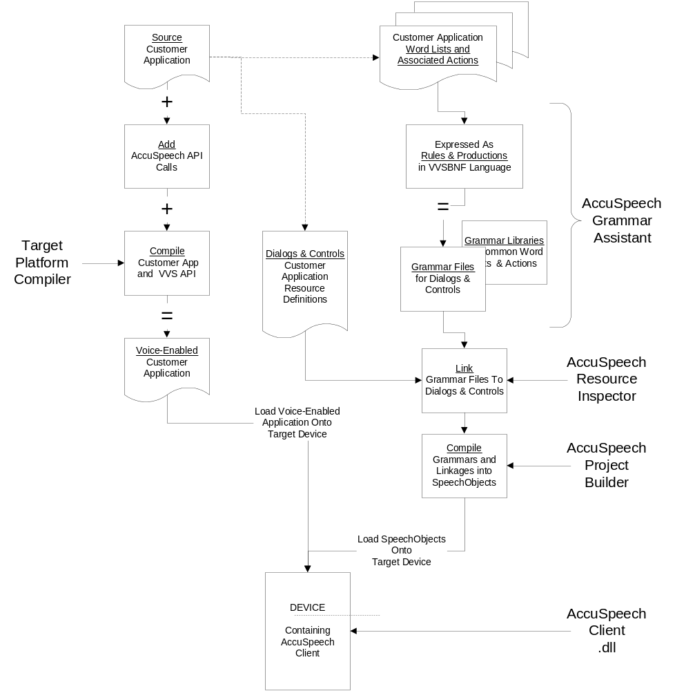

Elements of the AccuSPEECH™ Studio
The AccuSPEECH™ Studio integrates the following functions into a single application framework:

Project Management
Grammar Creation
Speech Object Definition
Project Building
Grammar Testing

In addition, the Studio integrates a simple text editor suitable for manually editing grammars and project definition files.

The structure of the Studio is shown below:

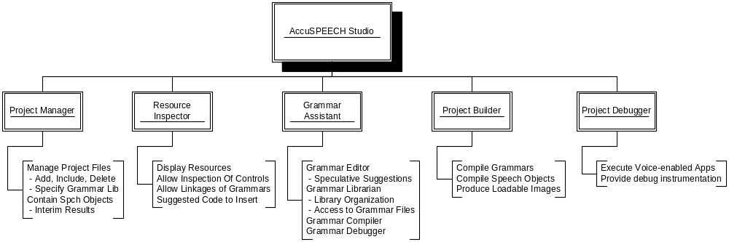

Project Management
The core of the system is the concept of the project. In order to use any of the handy automation features of the Studio one must create a project and work within the project. In general, the assumption is made that the application that is to be speech enabled is complete. Since speech enabling develops a parallel user interface that interacts with the traditional UI it makes sense for the definition of the application UI to be complete.

Creating a new project

On the menu bar of the AccuSPEECH™ Studio click: File -> New -> Project. The following screen will be presented.

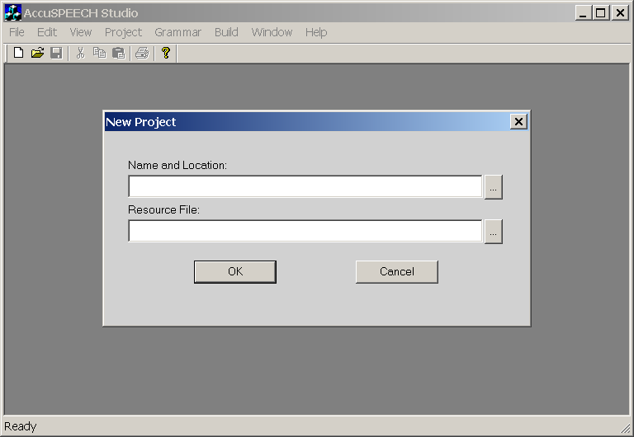

The buttons to the right of the edit boxes will open the standard Windows file requester dialogs. Two items will be required, the name and location of the new project file and the name of the Resource File that belongs to the application that is being speech enabled. We have found it organizationally useful to place all the AccuSPEECH™ files in a directory called GRAMMARS of the application’s project directory. You may, of course, place these files in any location you find convenient.

Once you have satisfied these two input requirements the Studio will prepare an empty project for you and create a default grammar set named ProjectNameGS. At this point there are no grammars in the grammar set. They will be added by either using the Grammar Wizard (see below) or by using the Add Grammar Files choices from the Project menu.

Exploring a Project
You may, at any time, view the active project by clicking View -> Project on the menu bar.

In this view, you will see the project tree, which has two main branches:
The Grammar Sets branch includes all the grammar sets and the individual grammars within the set.
The Resources branch includes all the resources in your specified resource file that can be voice-enabled.

As you develop your project using the Grammar Wizard and the Object Wizard (see below), the Resource branch of the project tree will be populated with the grammars you associate with each control within each dialog. You may double click on individual grammars and they will be opened in the grammar editor.

Building a Project
Projects may be built in two ways. By selecting the Build Project item in the Build menu the current project will be built. Once a project has been built a new file is created in the project directory, namely a .VDEF file for the project. At any time an arbitrary project may be built using the Build from Definition File item in the Build menu. Depending on your development style you may develop a preference for one or the other of these methods.

After a project is built, using either method, the build results will be output to the Project Build Results window. If an error was detected, it will be shown here. Clicking on the error message will open the appropriate grammar file and place the cursor on the offending line for remedial action.

Grammar Creation

Using the Grammar Wizard
The Grammar Wizard is available when a project is active. From the menu bar, click View -> Grammar Wizard. The following dialog will be displayed alongside an interactive image of the current dialog:

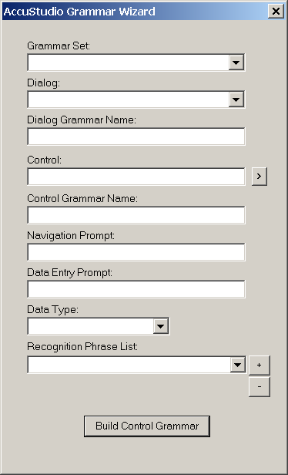

The Grammar Set pulldown will show the list of Grammar Sets that have been created for your application. If you created additional Grammar Sets you will want to select the Grammar Set with which you wish to associate the grammar(s) to be created.

The Dialog pulldown will show a list of all the dialogs that were defined in the resource file you specified when you created the project.

IMPORTANT NOTE: The Grammar Wizard creates a single grammar for the dialog as a whole. As a consequence it is vital that all work on a given dialog be completed in a single session before proceeding to the next dialog. Due to the interaction between dialog and control grammars it is possible for some of your work to be lost and need to be redone if you fail to observe this rule.

When you have selected a Dialog it is necessary to specify a Dialog Grammar Name. This is the name of the grammar that will include the commands that are available at all times when the dialog is active.

The Control box lists the controls that are available in the dialog. The arrow button to the right allows you to scroll through the inventory of controls in the dialog. The controls will be shown with their control ID and control type as defined in the resource script. Select the control you wish to enable.

The Control Grammar Name edit control exists to enable the definition of grammars that are peculiar to a specific field. For control types that have specific grammars for the input of data (an edit control, for example) this control is active. Fill in a name for the grammar to be associated with the currently selected control. Certain kinds of controls (buttons, for example) do not have control grammars so this field will be disabled if that is the type of the currently selected control.

The Navigation Prompt edit control is provided so that you can input the words which will move the cursor to the currently selected field. This is akin to tapping the control with a pen or mouse click. In the case of controls like pushbuttons where the tap or click causes action the text entered here will press the button. For example, if there was an edit control intended to receive a persons weight, the navigation prompt might be “weight”. When the dialog grammar is active saying “weight” would cause the cursor to snap to the field.

The Data Entry Prompt edit control is used to specify the introducing words leading to the input of data. Coupled with the Data Type field it generates a grammar which both moves the cursor to the field and fills it with the spoken value. Using the scenario above, the Data Entry Prompt migh be “weight is” and the Data Type, or an item from The Recognition Phrase List selection would probably be “number”. When the dialog grammar is active saying “weight is 160” would move the cursor to the weight field and place the value 160 in the control.

The Data Type pulldown contains the list of built in data types that are available for completion of data entry prompts. If appropriate this control will be enabled and you may select one of its members as the data type target for the current control.

The Recognition Phrase List combo box is an opportunity for you to specify a list of possible candidates for completion of your Data Entry Prompt. This control is available when the control type of the currently selected control is either LISTBOX or COMBOBOX. This control starts out empty and is populated by your additions. Type the members of your list into the control and press the “+” button to insert it into the list.

IMPORTANT NOTE: Enter your entries into this list IN EXACTLY THE SAME ORDER as they appear in your applications initialization code. Failure to have both the correct number and sequence of entries will result in incorrect behavior of your program.

The Build Control Grammar button is pressed when the entries for a control have been completed. The control grammar will be built and the current control will be advanced to the next control in the inventory.

When all the controls in a dialog have been completed you may advance to the next dialog or exit the Grammar Wizard by closing the dialog.

Using the Grammar Editor
When it is desirable or necessary to have complete control over the content of the grammar files, use the Grammar Editor. This allows you to create grammars entirely by hand.

On the menu bar, click File -> New -> File and you will be presented with a new grammar editing window. Create your grammar to conform to the BNF specification provided in Appendix C “AccuSPEECH BNF Language Definition” and save it as a .abnf file. Add the file a grammar set within your project using the Add Grammar Files item from the Project menu. Use the Object Wizard (see below) to then associate your newly created grammar with a control in a dialog.

Speech Object Definition

Using the Object Wizard
The Object Wizard is available when a project is active. From the menu bar, click View -> Object Wizard. The following dialog will be displayed along with an image of the currently selected dialog:

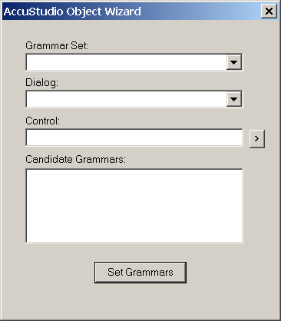

The purpose of the Object Wizard is to make it easy to associate specific grammars with specific controls. The AccuSPEECH™ system permits the association of any number of grammars with a dialog or control. Controls that require the same verbal input can share grammars as well. This feature gives the developer the maximum flexibility in designing their grammar sets with an eye to size and maintenance.

The Grammar Set pull down is used to select the grammar set from which the candidate grammars will be selected. As you select alternative grammar sets the list of items in the Candidate Grammar listbox will be replaced.

The Dialog pulldown is used to select the specific dialog on which to operate. As with the Grammar Wizard all operations on a given dialog should be completed prior to moving to the next.

The Control box lists the controls that are available in the dialog. The arrow button to the right allows you to scroll through the inventory of controls in the dialog. The controls will be shown with their control ID and control type as defined in the resource script. Select the control you wish to manipulate the grammar list for.

The Candidate Grammar list provides the mechanism to select one or more grammars to be associated with the currently selected control. This is a multiple selection listbox so you may select and unselect as few or as many grammars as you like.

The Set Grammars button should be pressed after you have completed your selection for a given control. Once you have completed your work you end your session by closing the Object Wizard.

Using a Text Editor
There are times when you may wish to perform tasks of grammar association that exceed the capabilities of the Object Wizard. For instance, if you wanted to associate multiple grammars with a given control but the grammars were not in the same Grammar Set. This is a perfectly legal choice but it exceeds the capabilities of the Object Wizard. Once the project has been built the project .VDEF file will be available for manipulation. Use the Open item from the File menu to open the .VDEF file for your project. You may now make any changes you need to make. See the AccuSPEECH™ Project Builder section of this manual for the definition of the formats used in this file.

IMPORTANT NOTE: Any changes made manually to the .VDEF file will be overwritten if you use the simple Build Project function. To protect your changes you must thereafter use the Build from Definition File choice to build your project. As an alternative you may wish to save your customized .VDEF file with a name other than the project name in order to protect your modification against inadvertent overwriting. As a practical matter manual manipulation of the .VDEF file should be left as the last stage of speech enabling.

Grammar Testing
The AccuSPEECH™ Studio provides a handy interactive desktop-based method for testing the behavior of your grammars. Once you have built your project you may exercise your grammars using the Grammar Exerciser. The Grammar Exerciser item is available when a project is active. From the menu bar, click Grammar -> Exercise. The following dialog will be shown alongside an image of your dialog:

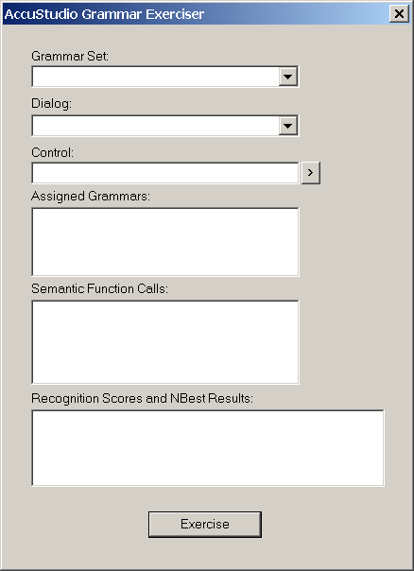

The purpose of this function is to allow the user to select a given grammar and try speaking to it and seeing the internal results. This is frequently useful in understanding exactly how and why a given combination of grammars when fed a particular speech input results in a given response.

This function assumes that your desktop computer is equipped with an AC ’97 compatible sound card and that a microphone suitable for speech recognition is attached to the sound card.

Select the Grammar Set, Dialog and Control you wish to exercise. The Assigned Grammars list will be updated to indicate the grammars that will be in effect during the test. To exercise a control, do the following:

- Click the Exercise button
- The system will emit a tone to prompt for input.
- Speak the test phrase into the microphone.
- When your input is complete, again click the button, which is now labeled “Stop” to end the test.
- The recognition results will be shown in detail in the Semantic Function Calls and Recognition Scores and Nbest Results controls.

Creating New Grammars – A Brief Tutorial

AccuSPEECH® Grammars use a very specific format and set of syntax rules. The complete definition of the syntax and features of the language is contained in Appendix C of this manual. It is sometimes necessary to create grammars from scratch without the aid of the AccuSPEECH® FormSuite’s Grammar Wizard. Doing so requires a fundamental understanding of the structure of a grammar file. A grammar file has the basic requirement that it contain a “START” rule. It is so called since it is the root entry for a grammar and the point at which the recognizer will begin the search for recognition matching.

For the purpose of this tutorial we will be creating a grammar to serve a dialog that contains two buttons. A copy of the code used in this tutorial is included as a sample on the installation CD.

Here is a picture of the dialog:

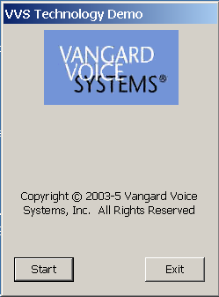

Since there will be two distinct actions to be performed (pressing the “Start” button or pressing the “Exit” button) the grammar will require two rules, one to handle each specific action. Here are the minimal rules to cause the recognizer to recognize these two commands:

#start = <StartPage>

<StartPage> = <startcmd> | <exitcmd>;

<startcmd> = START;
<exitcmd> = EXIT;

The first line is the special START rule referred to above. It indicates that the recognizer should work down the list of recognition possibilities defined by the symbol <StartPage>.
The next line is the definition of <StartPage>. It says that there are two possible rules <startcmd> and <exitcmd> that might be satisfied by this grammar.

The third and fourth lines are the actual rules. They indicate that the recognizer should be satisfied with “START” for the first rule and “EXIT” for the second rule.

An interesting point is that at the end of the day all non-terminal symbols (indicated by <> symbols) are finally resolved to terminal symbols. This is a fundamental requirement of all grammar files. The grammar will not build correctly if this requirement is not satisfied.

Our example is complete but it does not do anything yet, it only causes the recognizer to attempt to recognize the defined terminals. To make our grammar do something meaningful we must embellish it with Output Productions. The next step looks like this:

<startcmd> = START => DEPRESS(IDB_START);
<exitcmd> = EXIT => DEPRESS(IDB_EXIT);

Now we have indicated that if the recognizer hears “Start” the AccuSPEECH® system should cause the button with the Resource ID IDB_START to be pressed. Similarly, if the recognizer hears “Exit” the button with the Resource ID IDB_EXIT should be pressed.

Note that there is no inherent relationship between the text on the top of the button and the recognition targets. For example, the following embellishment causes the IDB_START button to pressed when either START or COMMENCE is recognized:

<startcmd> = (START | COMMENCE) => DEPRESS(IDB_START);

Once created and saved as an .abnf file the grammar must be added to one of your project’s grammar sets. This is accomplished by using the Add Grammar Files choice from the Project menu. You may then associate your new grammar with a user interface element using the Object Wizard.

Voice-Enabling Web Pages

Web-Based Applications

Using AccuSPEECH Studio (AccuStudio) to voice-enable a Windows application normally involves creating a studio project from the Resource file (application.rc and resource.h) associated with the application. This resource file is then analyzed by the studio, resulting in the creation of a number of speech objects representing those resource components which are candidates for voice activation. These speech objects include buttons, text edit windows, list boxes, menus, etc...

For Web-based applications, the absence of a resource file for a given Web page requires a different solution. The studio provides a tool to analyze the components of an HTML page to discover the speech object candidates. A resource file is then created to allow the studio to build a project associated with the Web application in the normal manner. The individual steps in the process are described below.

Preparing an HTML script

In order to voice-enable a Web application, the Web Server must generate an instrumented HTML script for the application page. Note: each Web page is considered to be an entire “application” with its own set of grammars. Only one Form is allowed per Web page. The required instrumentation protocol is described in Appendix A.

Analyzing a Web Application
- Run the AccuStudio and select the Analyze HTML command under the Tools menu.
- Enter the URL path to the Web application script to be analyzed and click OK.
- Your application Web page should be displayed, along with a message requesting confirmation that the AccuSpeech ActiveX control is allowed to interact (click Yes).
- Select the Generate – Create RC File command. At this point you will need to define the name of your project, which we refer to in this document as “MyProject”. Create a folder in which the generated AccuStudio project files for “MyProject” will be placed. Type in the project name and select OK.
- The following three files will be produced in the indicated directory:
  - MyProject.rc
  - MyProject.h
  - Myproject.log

- The information in the log file can be ignored except for any Warning messages. At the current time, the only warning message to pay attention to is the absence of an “ID” tag with a numeric string value for each input item that is to be speech-enabled. If the Server has not assigned an ID value to such an object, it cannot be speech-enabled.
- The “rc” and “h” files contain the specifications for the Speech Objects created for each input item detected.
- You may wish to leave the Analyze HTML screen active for the following steps since the HTML script display may be useful in making decisions with respect to grammar creation.

Creating an AccuStudio Project

- Select the AccuStudio File-New-Project command.
- Browse to the folder containing your MyProject files.
- Enter your “MyProject” name and select Save.
- For the resource file, browse and select the “MyProject.rc” file produced by the analysis phase described above and select OK.
- The project tree for the generated “MyProject” will be displayed. A Grammar Set is automatically produced along with a set of speech objects defined in the Resource tree node. These speech objects include a “Dialog” which corresponds to the form imbedded within the Web script. Note: an empty Resource tree indicates the absence of a form and associated objects, such as buttons, edit boxes, etc… In this case, there would be nothing to speech-enable for this Web page.

Creating Grammars for the Web-based Application

You may now use the AccuStudio Grammar Wizard to create the grammar files necessary to voice-enable the Web application as follows:

- Open your “MyProject” using the File-Open Project command.
- Invoke the AccuStudio Grammar Wizard with a Ctrl-W or View-Grammar Wizard command.
- The display window will show all speech objects derived from analyzing the HTML for the project. Note that this display shows a condensed version of the display in the Analyze HTML window.
- Fill in the prompt fields in the normal fashion (refer to the Grammar Wizard section within the AccuStudio manual).
- After exiting the Grammar Wizard, save the project using the File – Save command.
- Build the project using the Ctrl-B or Build-Build Project command. There should be no error messages for grammars created by the Wizard.

Running the Web Application

The following files need to be moved to the appropriate directory on the server:

- MyProject.ini
- MyProject.sbin
- MyProject.vbin
- MyProjectGS.bin
- MyProjectGS.vbin
- AccuSpeech.js

The indicated ‘js’ file is constant for all projects, and may reside in one location on the server.

The Web script must reference the INI file as follows:

AccuSPEECH.VVAppInit("http://thepath/MyProject.ini");
// “thepath” is the URL to the project.
AccuSPEECH.VVPageInit(Number(0));

You may now use the Internet Explorer to run your application script.

AccuSPEECH® SDK

Elements of the SDK

In addition to the FormSuite Studio the AccuSPEECH® SDK includes the include files, link libraries and runtime modules needed to actually implement the AccuSPEECH® system.

Since AccuSPEECH® is implemented for both X86 Win32 and PocketPC Win32 there are separate development files for the two platforms. The X86 versions reside in the \SDK\X86 branch of the AccuSPEECH® SDK CD while the PocketPC versions reside in the SDK\WINCE branch of the CD.

Within each platform branch there are INCLUDE and LIB directories. These directories contain the needed compile and link time components for their respective platform. You should include references to these directories in your development projects as locations for additional include and lib files, respectively.

Supported Development Environments

Target Platform | Supported Development Environment
Windows Mobile (Pocket PC 2003) | Microsoft Embedded Visual C++ Version 4
Windows 2000/XP | Microsoft Visual C++ Version 6

Note that it is not possible to execute the PocketPC version of AccuSPEECH® in the emulator provided with eVC4 due to limitations in the device virtualization. Remote debugging using eVC4 and ActiveSync is fully supported.

Theory of Operation

The basic principle at work in the AccuSPEECH® system is that given a defined set of grammars, unique identifiers for user interface objects and a definition of the type of user interface control it is possible to add speech recognition to an existing application with a minimal amount of code supplementation.

It is generally understood that in a Windows application written in C or C++ using either the native Windows API or MFC user input and interaction occurs within the context of windows, dialogs, menus and controls. Windows maintains a fairly rigid hierarchical relationship between a window and it’s contained controls.

AccuSPEECH® leverages this arrangement to maintain an internal monitor of program state which, in turn, is used to keep the recognizer context current with minimal intervention on the part of the application.

The basic events that must be tracked are application start and stop, window activation and input focus changes. The AccuSPEECH® SDK provides easy-to-call APIs to handle each of these events.

Source Code Integration

What follows is a brief introductory walkthrough of the most important features of the AccuSPEECH® API. The full documentation of the entire set of APIs can be found in Appendix B - AccuSPEECH® API Function Reference.

In order to compile and link an application that has been supplemented with these API calls you will need to add references to the AccuSPEECH® SDK files in your project. This entails adding the line #include “accuspeech.h” to each source file which contains references to the Vangard Voice APIs. Additionally you will need to add the appropriate link library to your project along with instructing the development environment where to find the library file. In the case of an application targeting the PocketPC the link library name is ACCUSPEECH.LIB. If you are targeting Windows 2000/XP the link library name is ACCUSPEECHW2K.LIB.

Application Startup
On application startup the VVAppInit API should be called to initialize the AccuSPEECH® system and load up all the necessary data. This function MUST succeed before any other AccuSPEECH® APIs can be called. Here is an example invocation from a Vangard sample program:

BOOL CNurseDemoApp::InitInstance()
{
VVAppInit("\\nursedemo\\nursedemo.vbin", ASR_MODE_PTT);

CNurseDemoDlg dlg;
m_pMainWnd = &dlg;
g_hInst = this->m_hInstance;
int nResponse = dlg.DoModal();
return FALSE;
}

Application Termination
On application termination the VVAppClose API should be called to cleanup all the resources which have been allocated during the application’s execution. Here is an example invocation in the same demo program shown above:

int CNurseDemoApp::ExitInstance()
{
VVAppClose();
return CWinApp::ExitInstance();
}

Window Activation
Whenever a window becomes active the VVDialogInit API should be called. We have found that this is best accomplished in response to a WM_ACTIVATE message when the low word of the wParam is not WA_INACTIVE. In the case of PropertyPages this can be accomplished most easily by handling the OnSetActive message.

The following code snippet is from a Vangard sample program written using MFC. It demonstrates handling the WM_ACTIVATE message from the application’s main window procedure:

LRESULT CNurseDemoDlg::WindowProc(UINT message, WPARAM wParam, LPARAM lParam)
{
if ((message == WM_ACTIVATE) && (LOWORD(wParam) != WA_INACTIVE))
{
VVDialogInit(this->m_hWnd, IDD_NURSEDEMO_DIALOG);
}
return CDialog::WindowProc(message, wParam, lParam);
}

Here is an example of the technique in the MFC handler for a PropertyPage:

BOOL Tab1::OnSetActive()
{
VVDialogInit(this->m_hWnd, IDD_TAB1);
return CPropertyPage::OnSetActive();
}

It is tempting to move this functionality to the handler for WM_INITDIALOG since your code probably already has a handler for that message. It is certainly effective there but you must still handle WM_ACTIVATE since modeless dialogs may gain, lose and regain focus without the dialog having been destroyed in the interim. WM_INITDIALOG messages are sent only once in the life of a dialog and will not be sent again when the dialog regains focus. It turns out that during dialog initialization a WM_ACTIVATE message is sent to the window so this handler works for all cases.

There is no problem calling VVDialogInit repeatedly even if there is no change implied.

Focus Changes
In order to keep the recognition context in synchronization with the application state it is vital that the AccuSPEECH® system is advised on a timely basis of changes in input focus. The VVFilterFocusMessages API was created to make this vital chore as easy as possible. It is called inside each window’s WM_COMMAND handler. Here is an example of calling the API from the same MFC sample program shown in previous examples:

BOOL Tab1::OnCommand(WPARAM wParam, LPARAM lParam)
{
VVFilterFocusMessages(wParam);
return CPropertyPage::OnCommand(wParam, lParam);
}

It is important that this API call is added to the WM_COMMAND handler for every window even if there are no grammars or speech objects defined for the window or its contained objects.

Starting and Stopping Recognition – PocketPC Style
All that remains now is for the application to tell the AccuSPEECH® system to start and stop listening. We provide easy to use APIs for the actual activation and deactivation of the recognizer. The application methodology is up to the application designer to specify. In the PocketPC handling the push-to-talk chore is easy since there are metakeys (the various buttons) available and special functions for managing them. Here is the code from a Vangard PocketPC demonstration program. This example uses Application Button 4 (the right most button on standard PocketPCs) as the activation key.

During application initialization:

BOOL bRes = RegisterHotKey(m_hWnd, 100, MOD_KEYUP | MOD_WIN, VK_APP4);

During application termination:

UnregisterHotKey(NULL,100);

Now just handle the WM_HOTKEY messages in the main window procedure as follows:

if (message == WM_HOTKEY)
{
if (LOWORD(lParam) != 0x08) VVStopListening();
else VVStartListening();
return TRUE;
}

Starting and Stopping Recognition – Windows 2000/XP Style
The WM_HOTKEY functions for desktop versions of Windows do not support the MOD_KEYUP notification message so it is not so easy to tell when the hotkey has been released. There are probably a dozen ways to get around this but the most straightforward we have found involves just examining the untranslated keystrokes and acting accordingly. Here is the technique shown in the now legendary Vangard MFC demonstration program:

BOOL CNurseDemoApp::PreTranslateMessage(MSG* pMsg)
{
if ((pMsg->message == WM_KEYUP) &&
(pMsg->wParam == VK_CONTROL))
{
VVStopListening();
return TRUE;
}
if {(pMsg->message == WM_KEYDOWN) &&
(pMsg->wParam == VK_CONTROL) &&
((pMsg->lParam & 0x40000000) == 0))
{
VVStartListening();
return TRUE;
}
return CWinApp::PreTranslateMessage(pMsg);
}

In this case the hotkey is the Control key on the keyboard. Changing the comparison of the wParam would change the hotkey. There are no doubt many optimizations possible this function which will perform better but this one is fairly easy to understand.

Speech Enabling Web Pages – Windows 2000/XP

Browser Requirements
The AccuSPEECH® ActiveX control supports Microsoft Internet Explorer versions 5.5 or higher. At the time of writing, version 6.02 SP2 had been successfully tested with the provided components.

Basic Web Page Requirments
In order to work properly with the AccuSPEECH® system some basic rules must be observed in the construction of webpages to be speech enabled.

First, and foremost, each INPUT tag, be it of type TEXT, TEXTAREA, SELECT, RADIO or BUTTON, whose object is going to be a target of speech must be provided with an ID attribute. This attribute must be an integer and it must be unique within the page. For example:

<input name="Temp" type="text" id=1008>

Second, only one FORM tag may be specified in a given page.

If these two rules are followed the process of speech enabling a web page is fairly straightforward.

HTML/Javascript Code Integration
Certain tags and code must be inserted into your HTML in order to speech enable your web page. The process closely tracks the process for enabling C and C++ programs. An important distiction is that since there is no persistance in HTML each web page stands on its own and is a complete “application” from the perspective of the AccuSPEECH® system.

The instructions which follow assume you have already created a set of grammar files for your page using the AccuSPEECH® Studio as described in that section of this manual.

Add the following to the <HEAD> section of your page:

<!-- AccuSPEECH OCX Control -->
<object classid="clsid:DF36BC79-4249-4FE8-8390-82EAEF7DBD71" ID="AccuSPEECH"></object>

<!-- AccuSPEECH Universal Javascript Include File -->
<script type="text/javascript" src="AccuSPEECH.js"></script>

<!-- AccuSPEECH Page Specific Initialization -->
<script type="text/javascript">
AccuSPEECH.VVSAppInit("http://yourserver/yourdirectory/your.ini");
AccuSPEECH.VVSPageInit(Number(0));
</script>

Note that if you intended to use Always-Listening Mode you would have added the following like immediately before the call to VVAppInit:

AccuSPEECH.VVSSetListeningMode(Number(1));

Modify the <BODY> tag of your page as follows:

<body onkeyup="VVSKeyFilter(event)" onkeydown="VVSKeyFilter(event)">

Note the addition of onkeyup and onkeydown attributes. This is used to satisfy the requirement to tell AccuSPEECH® when to start and stop listening. The function VVSKeyFilter is defined in the file AccuSPEECH.js which is included as part of the distribution. The “hotkey” is currently defined as the CTRL key on the keyboard. If you wished to change this you would want to edit the file.

Add the following code the the very end of your <FORM> section immediately above the </FORM> line:

<script type="text/javascript">
var x = document.getElementById('XXX');
x.focus();
AccuSPEECH.VVSFocusChange(Number(XXX));
</script>

Replace the XXX in the two function’s parameters with the ID of the first INPUT item in your page. This bit of code will set the focus to the item and synchronize the AccuSPEECH® system with your application’s state. Subsequent focus tracking will be taken care of by functions defined and activated in the AccuSPEECH.js file.

That is all there is to it! The only thing that remains to be done is to make sure all the referenced files are in the specified locations.

AccuSPEECH® is a registered trademark of Vangard Voice Systems, Inc.
All other trademarks or service marks are the property of their owners.
The information in this document describing AccuSPEECH® technology is proprietary to Vangard Voice Systems, Inc and covered by patents applied for and issued.

Appendices

Appendix A - Installation Instructions

Installing the AccuSPEECH® SDK
Installing the SDK files

Copy the entire contents of the \STUDIO directory on the AccuSPEECH® SDK CD to a directory of your choice on your hard disk. The only restriction is that no spaces are allowed in the names of any of the directories in the tree.
Installing the AccuSPEECH® Runtime

Follow the directions in the section entitled “Runtime System Configuration – Windows 2000/XP” in this Appendix to install the AccuSPEECH® runtime files needed to support the FormSuite Studio.
Create a Shortcut

You may find it convenient to create a shortcut to the ACCUSTUDIO.EXE file. This file will be found in the directory where you copied the files in the first part of this installation process. This shortcut may then be moved to the desktop or a menu for ease of access.

Runtime System Configuration – PocketPC

Device Configuration - IMPORTANT

It is vital for correct system operation for the Microphone AGC to be set to OFF and any optional Microphone Gain to be set to 0. These configuration items are set using the Audio or Microphone controls on the System tab of the Settings dialog. This is accessed by selecting Settings from the main PocketPC menu.

Failure to set this configuration properly will result in substantially inferior results.

Core System Support Files

The AccuSPEECH® system has a few basic runtime system configuration requirements. The following core system support files should be placed in the \WINDOWS directory of the target PocketPC device:

ACCUSPEECH.DLL
ECIENUS.SYN
ENGDATA.BIN
MVCWAVEIO.DLL

These files are found in the \POCKETPC\RUNTIME directory of the AccuSPEECH™ SDK CD.

By placing them in the \WINDOWS directory they will be sharable across all AccuSPEECH® speech enabled applications. Since some of them are of substantial size this becomes very important as the number of speech enabled applications on a given device increases.

Application Specific Files

Regardless of how your application was “speech enabled”, either by using the AccuSPEECH® FormSuite Studio or manually using your text editor and the command line utilities, the result will be a collection of output binary files produced by the AccuSPEECH® Project Builder. These files must be installed on the target PocketPC device in a location that will be accessible by your application at runtime.

The PocketPC version of Windows supports neither the concept of a “current working directory” nor a PATH statement. As a consequence of this limitation it is necessary that the files produced as the output of the AccuSPEECH® FormSuite Studio all be place in the same directory. The AccuSPEECH® API function VVInitApplication requires the full path and file name of the project .vbin file describing the recognition specification for your application as one of it’s arguments. All internal file references (grammar set files, and speech object defintions) are derived from the path you provide in your initialization call. You have complete freedom in the location of that directory.

The following is an example of the files that are produced by the AccuSPEECH® FormSuite Studio for a simple project named “TEST”:

TEST.VBIN
TEST.SBIN
TESTGS.VBIN
TESTGS.BIN

Because of the infinite variety of names and grammar set designs which are possible using the AccuSPEECH® FormSuite Studio it is quite likely that your set of files will not be this simple but it does provide a template of the files which must be installed on the runtime system.

Runtime System Configuration – Windows 2000/XP

Core System Support Files

The AccuSPEECH® system has a few basic runtime system configuration requirements. The following core system support files should be placed in the Windows system directory of the target system:

ACCUSPEECHW2K.DLL
ENGDATA.BIN
MVCWAVEIO.DLL
VOICECTL.DLL

These files are found in the \WINDOWS2K\RUNTIME directory of the AccuSPEECH® SDK CD.

By placing them in the WINDOWS system directory they will be sharable across all AccuSPEECH® speech enabled applications. Note that the actual name of the Windows System directory may be different from system to system. The only way to be certain of the directory name is to examine the system’s environment for the definition of the variable “windir” in the system environment.

Application Specific Files

Regardless of how your application was “speech enabled”, either by using the AccuSPEECH® Studio or manually using your text editor and the command line utilities, the result will be a collection of output binary files produced by the AccuSPEECH® Project Builder. These files must be installed on the target PocketPC device in a location that will be accessible by your application at runtime.

While the desktop versions of Windows do support the concept of a “current working directory” and a PATH statement for the sake of consistency with the PocketPC version it is necessary that the files produced as the output of the AccuSPEECH® FormSuite Studio all be place in the same directory. The AccuSPEECH™ API function VVInitApplication requires the fully qualified path and file name of the project .vbin file describing the recognition specification for your application as one of it’s arguments. All internal file references (grammar set files, and speech object defintions) are derived from the path you provide in your initialization call. You have complete freedom in the location of that directory.

The following is an example of the files that are produced by the AccuSPEECH® FormSuite Studio for a simple project named “TEST”:

TEST.VBIN
TEST.SBIN
TESTGS.VBIN
TESTGS.BIN

Because of the infinite variety of names and grammar set designs which are possible using the AccuSPEECH® FormSuite Studio it is quite likely that your set of files will not be this simple but it does provide a template of the files which must be installed on the runtime system.

Appendix B - AccuSPEECH® API Function Reference

VVAppInit
 | Called once per application to initialize the Vangard Voice Client engine with the data for the application.
ASRRC VVAppInit(LPCSTR lpAppConfigFileName, ASR_MODES nMode);
Parameters | Type | Description
lpAppConfigFileName | LPCSTR | Full path name to the application VBIN file to be used for this application.
nMode | ASR_MODES | The recognition mode to be used for this application.  See ASR_MODES for description
Returns | ASR_OK if no errors  See Error Codes for list of return error values
Comments

VVAppClose
 | Called once per application when the application terminates or is done with the recognition system.
ASRRC VVAppClose(void);
Parameters | Type | Description
Returns | ASR_OK if no errors  See Error Codes for list of return error values
Comments

VVDialogInit
 | Called to initialize the Vangard Voice recognition system for a given Dialog Box. May be called multiple times in the life of a dialog.
ASRRC VVDialogInit(HWND hDlg, UINT nDialogID);
Parameters | Type | Description
hDlg | HWND | Handle to the dialog instance. Since this function is typically called in response to the WM_INITDIALOG message this value is always at hand.
nDialogID | UINT | ID value used for the dialog. This must match the value used when creating the speech object. It is the value Windows uses to identify the Dialog Resource and is easily ascertained at compile time.
Returns | ASR_OK if no errors  See Error Codes for list of return error values
Comments | This function should be called anytime a dialog is gaining the topmost window position.

VVDialogClose
 | Called when an application wants to specifically disable the Vangard Voice recognition system but not close it. Not commonly used.
ASRRC VVDialogClose(void);
Parameters | Type | Description
Returns | ASR_OK if no errors  See Error Codes for list of return error values
Comments

VVFilterFocusMessages
 | Called by the application in its WM_COMMAND handler to determine if the current message is a focus changing message and handles the AccuSPEECH requirements if necessary. This function calls VVFocusChange internally.
ASRRC VVFocusChange(WPARAM wParam);
Parameters | Type | Description
wParam | WPARAM | The WPARAM argument to the WM_COMMAND message.
Returns | ASR_OK if no errors  See Error Codes for list of return error values
Comments | This function is provided as a convenience. It checks whether the incoming WM_COMMAND message is a focus change notification message (EN_SETFOCUS, BN_SETFOCUS, CBN_SETFOCUS, LBN_SETFOCUS) and calls VVFocusChange internally.
VVFocusChange
 | Called by the application to advise the Vangard Voice recognition system that input focus has changed. Correctly calling this function is vital to the correct behavior of the system. Largely superceded by the VVFilterFocusMessages function.
ASRRC VVFocusChange(UINT nControlID);
Parameters | Type | Description
nControlID | UINT | The resource ID of the control receiving focus. This is typically retrieved from processing the notification messages for the dialog.
Returns | ASR_OK if no errors  See Error Codes for list of return error values
Comments

VVStartListening
 | Called by the application to start the recognition process. Recognition will proceed using the combination of grammars defined and activated in the VVDialogInit and VVFocusChange functions.
ASRRC VVStartListenting(void);
Parameters | Type | Description
Returns | ASR_OK if no errors  See Error Codes for list of return error values
Comments

VVStopListening
 | Called by the application when it wishes to stop recognition. All pending buffers are sent for recognition and the Vangard Voice recognition system is suspended.
ASRRC VVStopListening(void);
Parameters | Type | Description
Returns | ASR_OK if no errors  See Error Codes for list of return error values
Comments

VVAddSpeechObject
 | Called by an application which wishes to create a new SpeechObject dynamically to an existing dialog box. This is an advanced function.
ASRRC AddSpeechObject(UINT nDialogID, UINT nControlID, VCONTROLTYPE vt);
Parameters | Type | Description
nDialogID | UINT | Resource ID of the dialog for which a new SpeechOjbect is being created.
nControlID | UINT | Resource ID of the control for which the new SpeechObject is being created. Ignored if vt is DIALOG
vt | VCONTROLTYPE | Type of the control for which the SpeechObject is being created. See the documentation for the VCONTROLTYPE enumeration for specific values.
Returns | ASR_OK if no errors  See Error Codes for list of return error values
Comments

VVAddGrammar
 | Called by an application to dynamically add a grammar to an existing SpeechObject. This is an advanced function.
ASRRC VVAddGrammar(UINT nDialogID, UINT nControlID, UINT nGramSetOrdinal, UINT nGramOrdinal);
Parameters | Type | Description
nDialogID | UINT | Resource ID of the dialog which contains the control to which the grammar will be added.
nControlID | UINT | Resource ID of the control to which the grammar will be added.
nGramSetOrdinal | UINT | Ordinal of the Grammar Set which contains the grammar to be added.
nGramOrdinal | UINT | Ordinal of the Grammar within the Grammar Set of the specific grammar to be added.
Returns | ASR_OK if no errors  See Error Codes for list of return error values
Comments

VVClearGrammars
 | Called by an application to clear the grammar list for the current instance of a specific control in a dialog. This is an advanced function.
ASRRC VVClearGrammars(UINT nDialogID, UINT nControlID);
Parameters | Type | Description
nDialogID | UINT | Resource ID of the dialog box which contains the control to be operated upon.
nControlID | UINT | Resource ID of the control for which the grammar list is to be cleared.
Returns | ASR_OK if no errors  See Error Codes for list of return error values
Comments

Appendix C - AccuSPEECH® BNF Language Definition
This document describes the syntax and use of the Vangard AccuSPEECH® Grammar definition language. This language is intended to allow the AccuSPEECH developer to specify the behavior of a Grammar, also referred to as a Vocabulary, with respect to constructs to be recognized and subsequent navigation and/or data entry operations to be performed.

LANGUAGE ELEMENTS

Constructs of the language fall into one of the following categories:

- Comments
- Terminals (string constants)
- Non-Terminals (rule variables)
- Grammar Rules
- Output productions
- Declarations

LANGUAGE DEFINITION CONVENTIONS

- AcccuSPEECH BNF is a case sensitive language.
- Use of special characters within a Terminal string follows the “C” convention (they are preceded by the escape character (“\”)).
- White space is not significant except within quoted Terminal strings, rule variable definitions, and as a separator for unquoted terminals.

LANGUAGE CONSTRUCTS
Comments

A comment is initiated with a double slash (“//”) occurring anywhere within a line. All characters up to the next line are ignored.
Terminals

Terminals are recognition strings optionally enclosed in quotation marks. They are case-insensitive since case does not affect user pronunciation.

Examples:

Moonlight in Vermont | Three separate words.
“moonlight” “in” “vermont” | Same as first example.
“Moonlight in Vermont” | A phrase treated as a single word (no pauses).
Non-Terminals

A Non-Terminal is the name of a rule definition enclosed in mandatory angle brackets (“<” and “>”). A Non-Terminal cannot cross a line boundary.

Examples:

<number>
<digit>
<Election_Data>
Grammar Rules

A grammar rule consists of a collection of constructs that identify words to be recognized in a user utterance. It consists of an identifier for the rule name (rule <id>), followed by an “=” sign, followed by a Rule Expression, followed by a semicolon (“;”). A given rule name can be defined only once in the entire grammar.

<id> = Rule Expression ;

White space characters are not significant except within quoted terminal strings. A Rule Expression consists of one or more Alternatives, each separated by the alternative operator (“|”):

<name> = JOHN | SAM;

An Alternative consists of a sequence of Operands separated by spaces or special characters. An Operand is one of the following:

- Terminal
- Non-Terminal
- Sub-Expression enclosed with parenthesis (“(“ and “)”). A Sub-Expression is a Rule Expression without an assignment to a rule id.

A repeat modifier may optionally follow each Operand:

- + Implies one or more occurrences.
- * Implies zero or more occurrences.

Enclosing an operand in brackets (“[“ and “]”) implies the Operand is optional (occurs 0 or 1 times).

Examples:

… One Hundred [and] Fifty Dollars … // “and” is an optional utterance

<even digit> = 0 | 2 | 4 | 6 | 8 ;
<odd digit> = 1 | 3 | 5 | 7 | 9 ;
<digit> = <even digit> | <odd digit>;
<digits> = <digit>+ ;
<command> = ( <digit> Volts | <directive>) <terminator> ;
Output Productions

At recognition time, one or more AccuSPEECH grammar definitions will be applied to a user utterance. The one that matches a user utterance will yield a collection of recognized words. In order to support navigation and data entry activities, an AccuSPEECH grammar must allow the developer to specify transformation rules, termed Productions, to map these words into a stream of formatted commands.

A Production may occur in one of the following places:
- Immediately following a terminal.
- At the end of a “#start” rule (refer to the example below).

The Production syntax is as follows:

=> Production_Operand [+ Production_Operand …]

A Production_Operand consists of a sequence of Terminal, Non-Terminal, or Function References, separated by a “+” .

A Function Reference is a call to one of a number of pre-defined semantic routines within the AccuSPEECH Client module. The available rules are defined below.

Examples:

// Simple Terminal mapping Productions:

<digit> = one => 1 | two => 2 | three => 3 | four => 4 |
five => 5 | six => 6 | seven => 7 | eight => 8 | nine => 9 ;

<month> = January => 1 | February => 2, …
<day> = First => 01 | second => 02 , …

// Production outputting the strings recognized by the indicted rules:

<date> = <month> <day> => <month> <day> 2003 ;

#define PainField 1031

// Data entry to an edit field:

<PainEdit> = <nonzerodigit> => SETFIELD(PainField, <nonzerodigit>);

// Focus change:

<PainFocus> = PAIN => SETFOCUS(PainField);

// Use of a Production for a main “#start” rule:

#start <PATIENT>

<PATIENT> = <patient> => SELECTITEM(IDL_PATLIST, _data_);

A Production with references to Terminal or Non-Terminals always yields a string consisting of the concatenation of the terminal or non-terminal operands. The string value of a reference to a non-terminal (Rule Name) is one of the following:

- The concatenation of all of the terminal words recognized by the rule.
- If the rule has any productions, the rule value is the concatenation of all these productions.

The special construct “_data_” is provided to access the concatenation of all terminals recognized by any rules:

<tempnumber> = <twodigit> [POINT=>"." <onedigit>];
<dtemp> = TEMPERATURE IS => SETFIELD(IDE_TEMP, _data_) <tempnumber>;

A more complicated use of the “_data_” construct is as follows:

<dbloodpressure> = BLOOD PRESSURE IS => SETFIELD(IDE_SYSTOLIC, _data_) + SETFIELD(IDE_DIASTOLIC, _data_) <number> OVER => "|" <number>;

This example allows a single utterance, such as “BLOOD PRESSURE IS 175 OVER 78” to be recognized with data automatically entered into the Systolic and Diastolic data fields. Note the use of the separator “|”. This allows the two blood pressure numbers to be separated into two values for “_data_”. The first is placed into the Systolic field, the second in the Diastolic field.

A Function Reference does not yield a string result. Its purpose is to invoke one or more of the semantic handling routines within the AccuSPEECH Client module. The following routines are currently defined:

SETFIELD(controlID, string value)
APPENDFIELD(controlID, string value)
SETFOCUS(controlID)
CLEARFIELD(controlID)
SAYFIELD(controlID)
SAYSTRING(string value)
DEPRESS(buttonID)
SELECTITEM(controlID, index number)
SELECTTAB(tabnumber)
NAVIGATE(controlID, navigation code)
SETRADIO(selectID, firstID, lastID)
SETDATETIME(controlID, year, month, day, hour, minute)
SELECTMENUITEM(menuID)

Please refer to the AccuSPEECH™ BNF Function Reference for detailed information concerning the semantic handling routines and their use.

Notes on Productions:

- White spaces in a Production are ignored. To insert a space in the Production string, use “ “ as an operand. A Production is terminated by a special character ending an Alternative, such as “(“, “(“, “|”, or “;”.
- The AccuSPEECH runtime interpreter expands the Productions of the various recognized rules to assign string “values” to each such rule. The root rule definition, associated with the Start rule specified in the START Declaration, produces the final Production string, if any.
Declarations

The following Declaration Statements may occur anywhere in the input on a single line:

- The “include” statement:

#include “filespec”

Characters are retrieved from the file “filespec” until and end-of-file is encountered. #includestatements may be nested up to 16 levels.

Examples:

// Include the Vangard utility rule definitions in “utils.abnf”
#include “utils”

// Include the project resource header file
#include “resource.h”

If a file is a header file of the form “*.h”, its contents are scanned for “#define” statements (as defined below) and all other constructs are ignored. This allows values to be assigned to application dialog and control field names, such as contained within an application resource file.

A filespec which is not a header file is assumed to be an AccuSpeech BNF file with the name “filespec.abnf”.

- The “start” directive:

#start <rulename>

The indicated rule is marked as a root definition. The grammar is successfully applied to a user utterance if and only if one of the Alternatives of this root is satisfied. The rule definition may appear anywhere within this same file.

Example:

#start <IntroGrammar>

<IntroGrammar> = <Login> | <Exit>;

- The “define” statement:

#define <name> <string>

This statement is functionally equivalent to a “C” #define statement.

Examples:

#define IDB_LOGIN 1000
#define IDB_EXIT 1001

EXAMPLES

// Patient Name

<LastName> = JONES | DICKERSON | SIMPSON ;
<FirstName> = MARY | CYNTHIA | BILL;

<PatientName> = (<FirstName> <LastName> | <LastName> <FirstName)
=> <LastName> ”, “ <FirstName>;

// Vitals Dialog

#include utils.bnf
#include "resource.h"

<fieldedit> =
CLEAR FIELD => CLEARFIELD(0) |
SAY THAT => SAYFIELD(0) ;

<tempnumber> = <twodigit> [POINT=>"." <onedigit>];

<VITALS> = <dtemp> | <dpain> | <dbreathing> | <dsystolic> |
<ddiastolic> | <dbloodpressure> | <dclear> | <dcancel> |
<fieldedit>;

<dtemp> = TEMPERATURE IS => SETFIELD(IDE_TEMP, _data_) <tempnumber> |
TEMPERATURE => SETFOCUS(IDE_TEMP);

<dpain> = PAIN LEVEL IS => SETFIELD(IDE_PAIN, _data_) <onedigit> |
PAIN LEVEL => SETFOCUS(IDE_PAIN);

<dbreathing> = BREATHING IS => SETFIELD(IDE_BREATHING, _data_)
<number> | BREATHING => SETFOCUS(IDE_BREATHING);

<dsystolic> = SYSTOLIC IS => SETFIELD(IDE_SYSTOLIC, _data_) <number> |
SYSTOLIC => SETFOCUS(IDE_SYSTOLIC);

<ddiastolic> = DIASTOLIC IS => SETFIELD(IDE_DIASTOLIC, _data_) <number> |
DIASTOLIC => SETFOCUS(IDE_DIASTOLIC);

<dbloodpressure> = (BLOOD PRESSURE | BEE PEE) IS =>
SETFIELD(IDE_SYSTOLIC, _data_) + SETFIELD(IDE_DIASTOLIC, _data_)
<number> OVER => "|" <number>;

<dcancel>= CANCEL => DEPRESS(IDCANCEL);

<dclear>= CLEAR => DEPRESS(IDB_CLEAR);

Appendix D - AccuSPEECH® Semantic Function Reference

SETFIELD
 | Sets the contents of the control with the specified ID (field_id) to the specified value (string_value).
SETFIELD(field_id, string_value)
Parameters | Type | Description
field_id | int | Control ID of the control whose contents are to be set to the supplied value.
string_value | C string | Null terminated ANSI string representation of the data to be inserted into the specified control.
Returns
Comments

APPENDFIELD
 | Append the string_value to the contents currently in the control whose ID is equal to field_id. Only valid for controls of the EDITTEXT type
APPENDFIELD(field_id, string_value)
Parameters | Type | Description
field_id | int | Control ID of the control whose contents are to be appended
string_value | C string | Null terminated ANSI string to be appended to the current control contents.
Returns
Comments

SETFOCUS
 | Set the input focus to the control whose ID is equal to field_id.
SETFOCUS(field_id)
Parameters | Type | Description
field_id | int | Control ID of the control to which input focus will be given. Must be a valid control in the current window.
Returns
Comments

CLEARFIELD
 | Clear the contents of the control whose ID is equal to field_id. Only valid for controls of the EDITTEXT type.
CLEARFIELD(field_id)
Parameters | Type | Description
field_id | int | Control ID of the control whose contents will be cleared.
Returns
Comments

SAYFIELD
 | Send the contents of the control whose ID equals field_id to the Text-To-Speech synthesizer
SAYFIELD(field_id)
Parameters | Type | Description
field_id | int | Control ID of the field whose contents are to be sent to the Text-To-Speech synthesizer to be spoken. If a field has a current selection, only the selection is sent.
Returns
Comments

SAYSTRING
 | Send string_value to the Text-To-Speech synthesizer.
SAYSTRING(string_value)
Parameters | Type | Description
string_value | C string | Null terminated ANSI string to be spoken by the Text-To-Speech synthesizer
Returns
Comments

DEPRESS
 | Simulate the pressing of the button whose ID is equal to button_id.
DEPRESS(button_id)
Parameters | Type | Description
button_id | int | Control ID of the button to be depressed.
Returns
Comments

SELECTITEM
 | Set the selection of the listbox, combobox or listview whose ID is equal to list_id to the ordinal value equal to item_ordinal.
SELECTITEM(list_id, item_ordinal);
Parameters | Type | Description
List_id | Int | Control ID of the list type control to be affected by the selection.
Item_ordinal | Int | Zero based ordinal of the item within the list type control to be selected.
Returns
Comments

SELECTTAB
 | Set the tab_ordinal tab of a Property Sheet to the top sheet.
SELECTTAB(tab_ordinal)
Parameters | Type | Description
tab_ordinal | int | Zero based ordinal of the Property Page of the current Property Sheet to be made the top page
Returns
Comments

NAVIGATE
 | Send the nav_character keycode to the control whose ID is equal to control_id.
NAVIGATE(control_id, nav_character);
Parameters | Type | Description
control_id | int | Control ID of the control to receive the navigation keycode.
nav_character | int | One of the following constants:  VK_UP,  VK_DOWN,  VK_LEFT,  VK_RIGHT,  VK_HOME,  VK_END,  VK_PRIOR,  VK_NEXT  The defined keycode must be valid for the control type. For example, VK_LEFT has no meaning in a simple Listbox control.
Returns
Comments

SETRADIO
 | Set the current radio button to the control whose ID is equal to button_id in the range of radio button controls bounded by the ID values in buttonlow and buttonhigh.
SETRADIO(button_id, buttonlow, buttonhigh);
Parameters | Type | Description
button_id | int | Control ID of the radio button to be selected
buttonlow | int | Control ID of the first radio button in the sequence to be affected by the selection
buttonhigh | int | Control ID of the last radio button in the sequence to be affected by the selection
Returns
Comments

SETDATETIME
 | Set the Date/Time Picker control whose ID is equal to control_id to reflect the values specified in the year, month, day, hour and minute parameters.
SETDATETIME(control_id, year, month, day, hour, minute);
Parameters | Type | Description
control_id | int | Control ID of the Date/Time Picker control whose values are to be set by this function call
year | int | Year to be set. Valid range is 1900 to 2037.
month | int | Month to be set. Valid range is 1 to 12.
day | int | Day of month to be set. Valid range is 1 to 31 but must be valid for the selected month in the selected year.
hour | int | Hour of the day to be set. Valid range is 0 to 23.
minute | int | Minute of the hour to be set. Valid range is 0 to 59.
Returns
Comments

SELECTMENUITEM
 | Simulate the selection of the menuitem whose ID is equal to the menu_id parameter.
SELECTMENUITEM(menu_id);
Parameters | Type | Description
menu_id | int | Menu id value of the item to be selected. The selection will be accomplished by sending a WM_COMMAND message with the menu_id properly encoded in the wParam field of the Windows message structure.
Returns
Comments

Appendix E – AccuSPEECH® ActiveX/COM Interface Reference
Introduction
For each supported Microsoft Windows platform which provides a suitable version of the Internet Explorer browser an ActiveX/COM module is provided as part of the runtime client installation. Not all versions of Windows have a suitable browser. Contact Vangard Voice Systems support if you are unsure whether the version of Windows you wish to deploy your application on supports the AccuSPEECH® ActiveX control.

CLSID Information
In order to reference and call functions exposed by an ActiveX control it is required that you have included and <OBJECT> tag in your HTML document. This tag has two important elements the CLASSID and the ID. You can use whatever HTML conforming ID you like but the CLASSID must match the one in the registry when the ActiveX control was installed. Below are the CLASSIDs used by AccuSPEECH®:

Windows 2000/XP

clsid:DF36BC79-4249-4FE8-8390-82EAEF7DBD71

Windows PocketPC2003

clsid:69F440BD-5403-488A-982B-038D6EE2CD67

Windows CE Version 4.3

clsid:7EC4928D-EE09-414A-B0C5-F8E95163B25E

Methods Exposed
The AccuSPEECH® ActiveX/COM module provides a subset of the functions provided by the C/C++ API. The balance of this appendix is devoted to documenting the method exposed by the ActiveX interface.

VVSSetListeningMode
 | Determines how the recognizer will be operated once VVSStartListening is called. MUST be called prior to VVAppInit().
VVSSetListeningMode(long nListeningMode);
Parameters | Type | Description
nListeningMode | Long | The desired listening mode.  0 = Push-To-Talk mode  1 = Always Listening mode
Returns
Comments

VVSAppInit
 | Initialize the AccuSPEECH® engine module.
VVSAppInit(BSTR lpAppConfigFile);
Parameters | Type | Description
lpAppConfigFile | BSTR | HTTP URL of the .ini file created for the page by the AccuSPEECH® Studio. The grammar files MUST be located in the same server directory as the .ini file.
Returns
Comments

VVSPageInit
 | Initialize the grammars for the the current web page.
VVSPageInit(long nPageID
Parameters | Type | Description
nPageID | Long | FORM ID for the current page. If the <FORM> tag did not include a numeric ID attribute the AccuSPEECH® Studio will have generated a default ID value of 0. This function MUST be called for each page.
Returns
Comments

VVSFocusChange
 | Informs the AccuSPEECH® engine that there has been a focus change.
VVSFocusChange(long nCurrentFocusID);
Parameters | Type | Description
nCurrentFocusID | Long | ID value of the INPUT item which has received focus.
Returns
Comments

VVSStartListening
 | Starts the flow of audio input to the recogizer.
VVSStartListening();
Parameters | Type | Description
Returns
Comments

VVSStopListening
 | Halts the flow of audio input to the recognizer.
VVSStopListening();
Parameters | Type | Description
Returns
Comments

VVSPageClose
 | Empties the active grammar list and cleans up the current page.
VVSPageClose();
Parameters | Type | Description
Returns
Comments
Rarely used.

VVSAppClose
 | Terminates the AccuSPEECH® recognition service. Must be called on the termination of each page.
VVSAppClose();
Parameters | Type | Description
Returns
Comments

Frequently called in window.onunload

